**IONIC EQUILIBRIUM**

**Theory of Acids and bases**

**Arrhenius Theory**

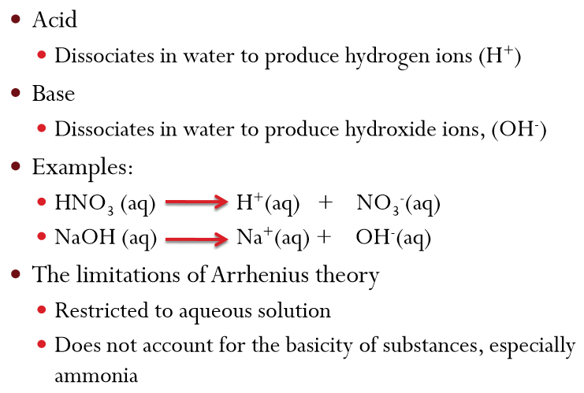

**BrØnsted – Lowry Theory**

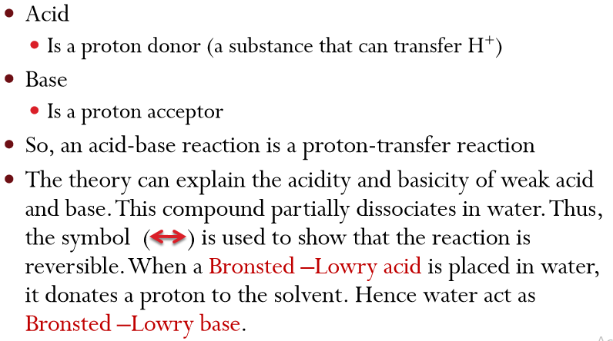

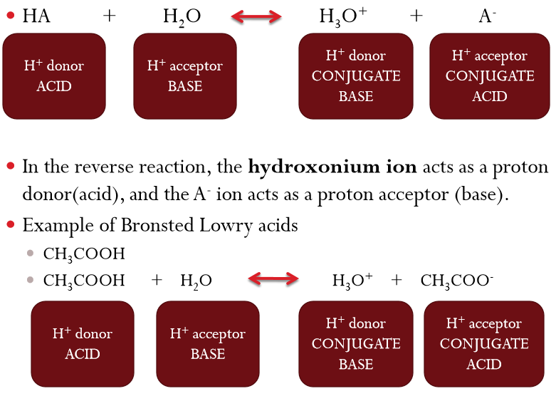

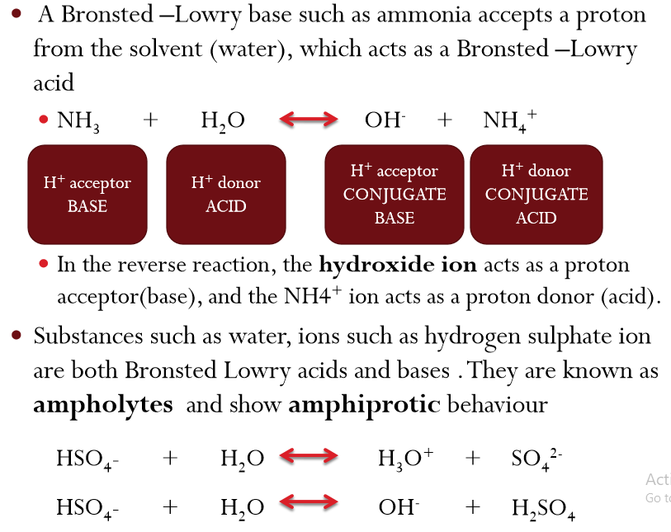

**Exercises**

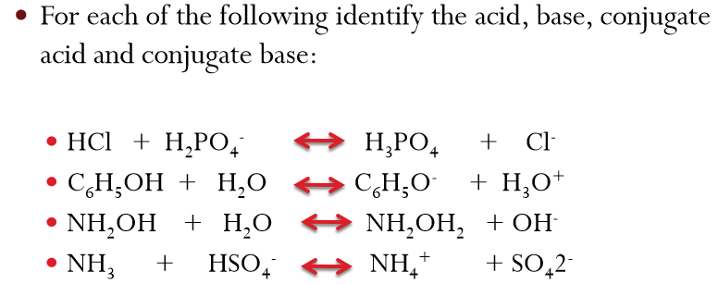

**Lewis Theory** 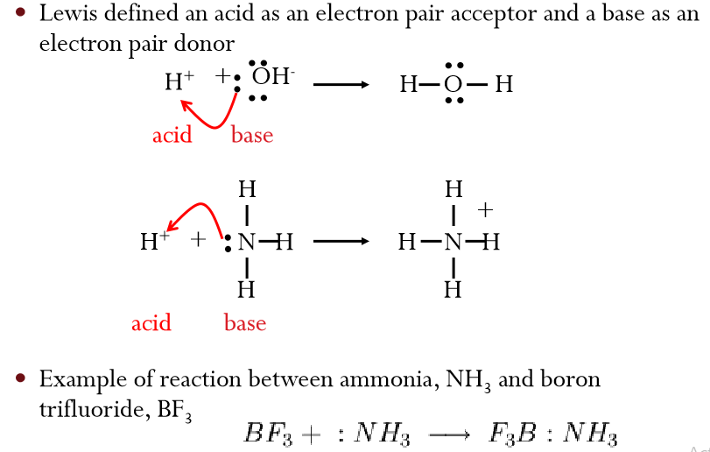

**Relative Strength of Bronsted –Lowry Acids and Bases**

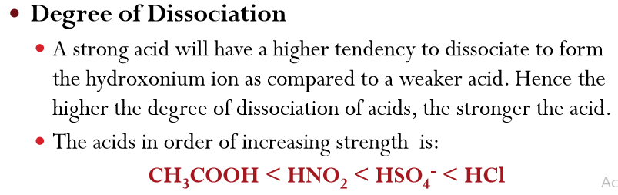

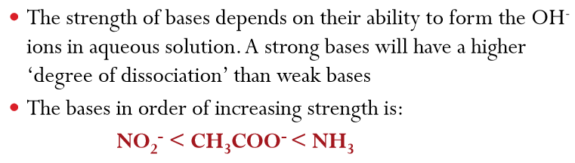**Acid/Base Dissociation Constant (Ka and Kb)** 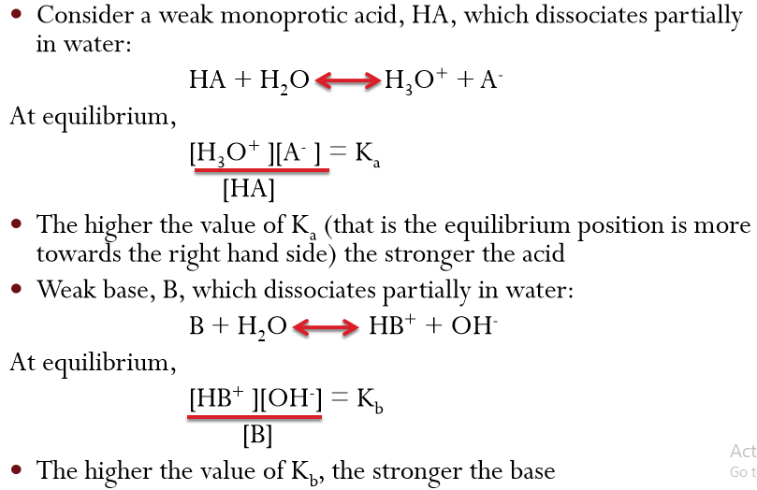

**pKa and pKb**

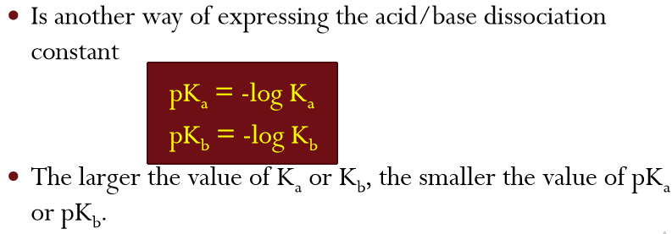

**Ostwald Dilution Law and Dissociation Constant**

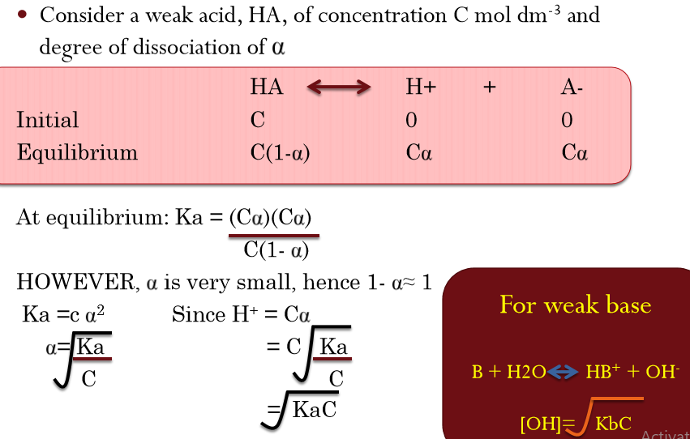

**Ionic Product of Water**

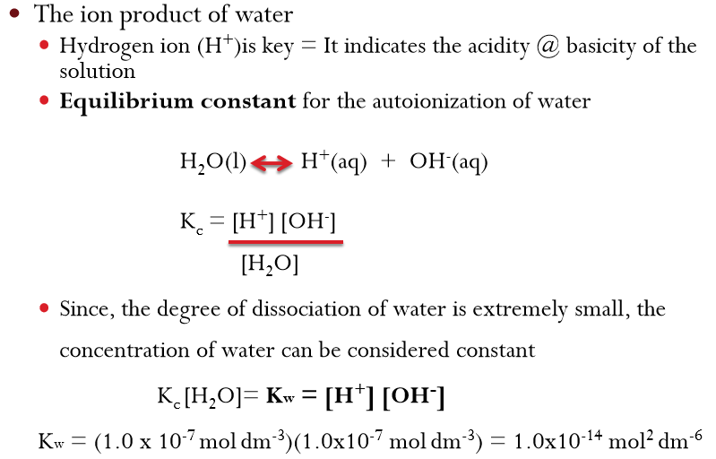

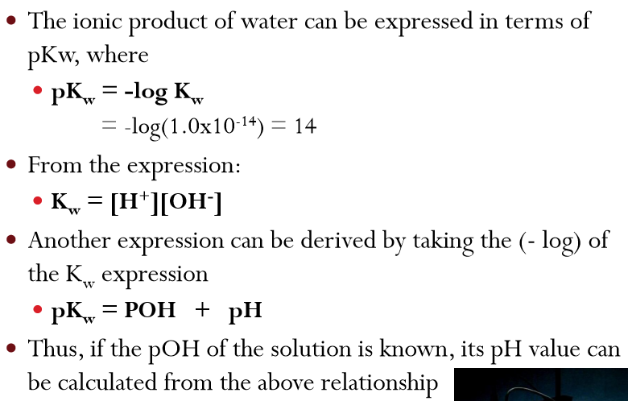

**Measurement of acidity and basicity**

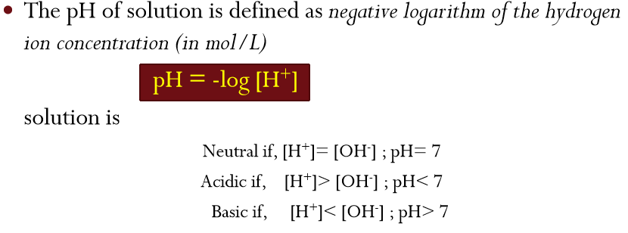

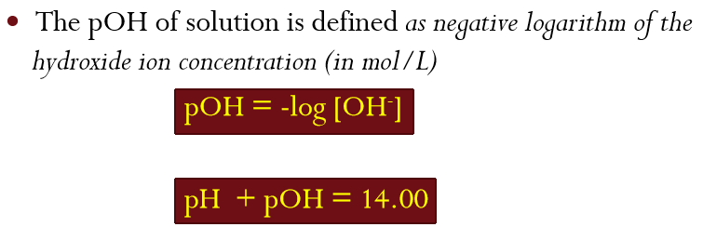

**Relationship between pKa, pKb and pKw**

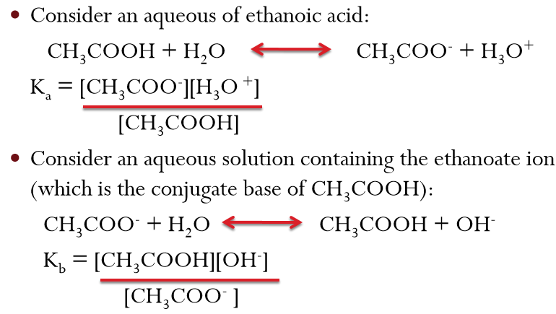

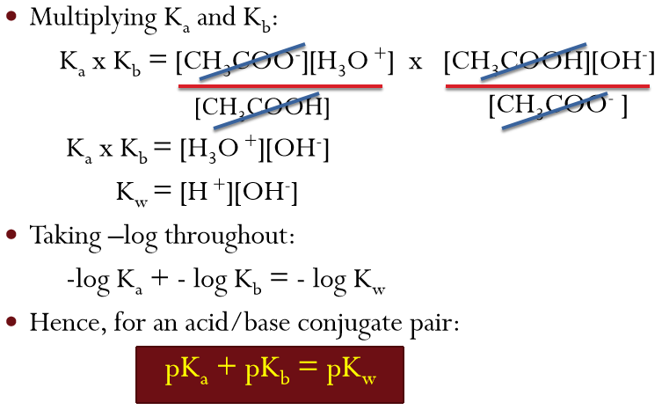

**Example**

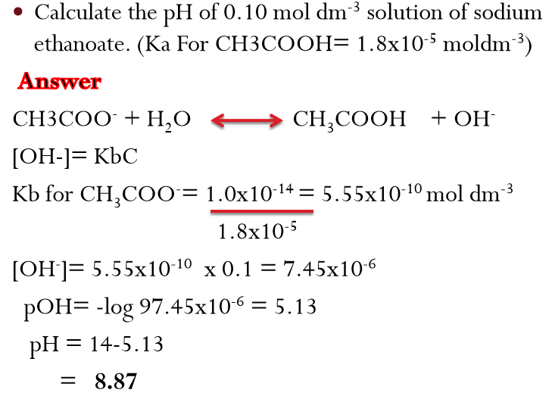

**Acid-Base Titration**

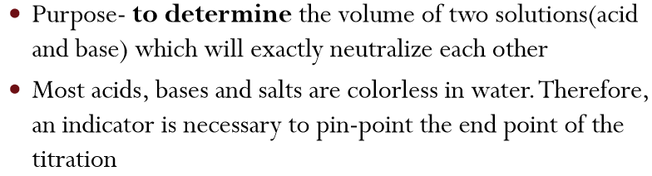

**Acid-Base Indicators**

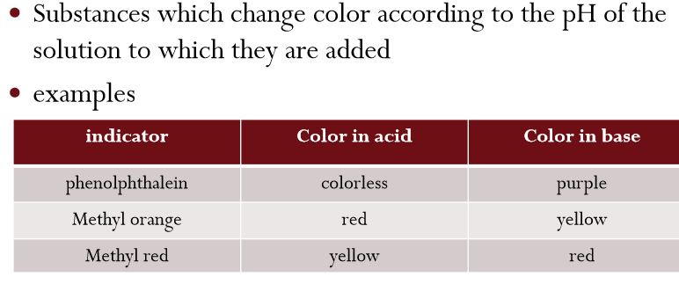

**Equivalent point and End point of Acid Base Titration**

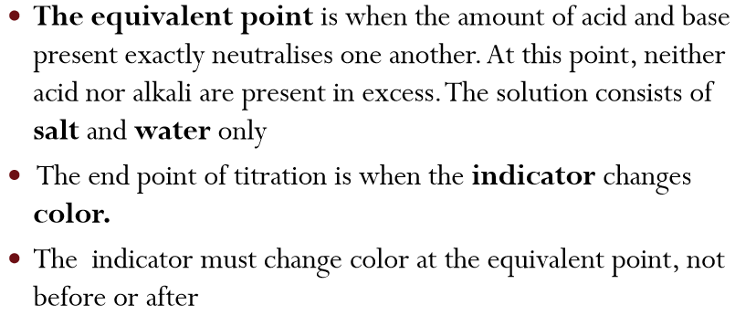

**Suitable Indicator**

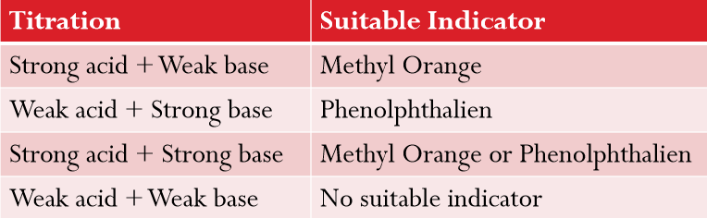

**Acid-Base Properties of Salts**

**Neutral Solutions:**

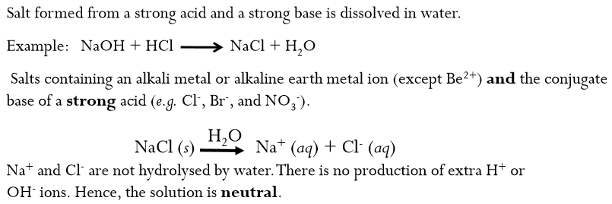

**Basic Solutions:**

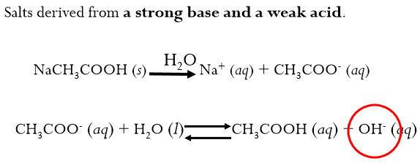

**Acid-Base Properties of Salts**

**Acidic solution.**

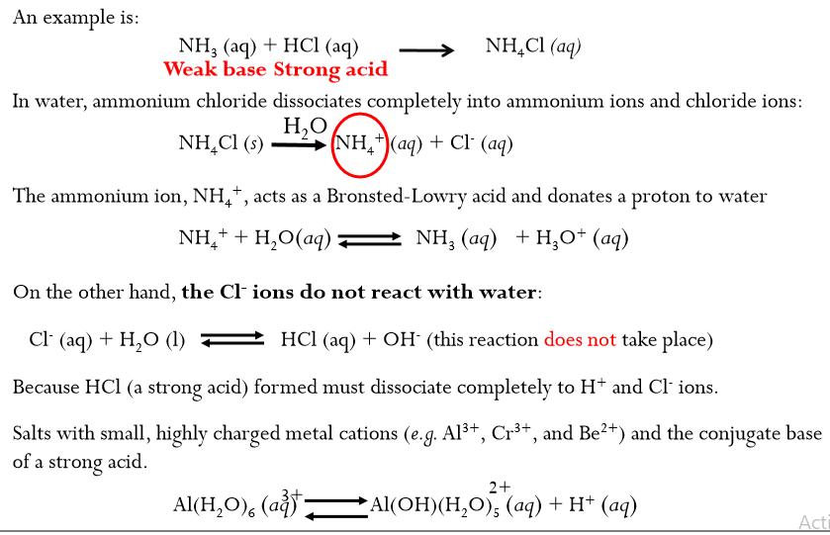

**Acid Hydrolysis of Al3+**

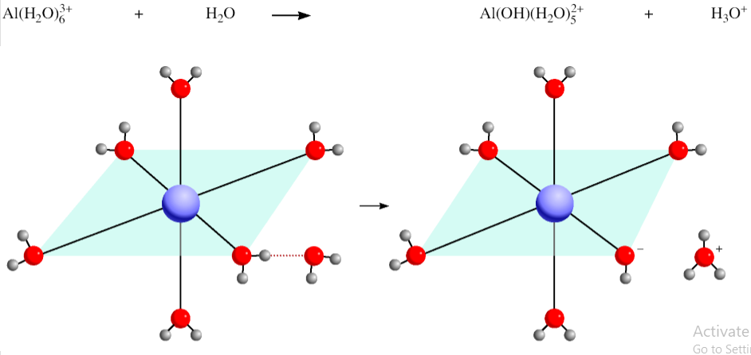

**Acid-Base Properties of Salts**

Solutions in which both the cation and the anion hydrolyze:

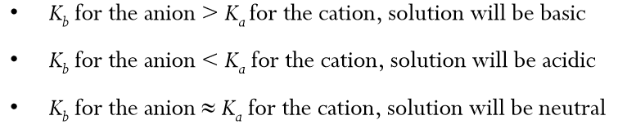

**Acid-Base Properties of Salts**

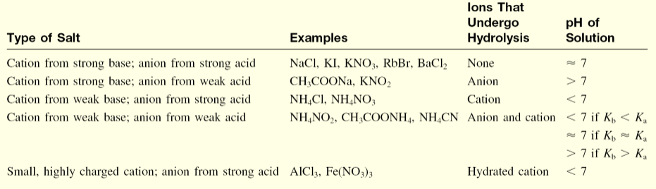

**Hydrolysis**

Remembering the following equations must hold simultaneously

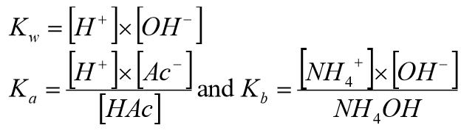

Also, it can be shown that

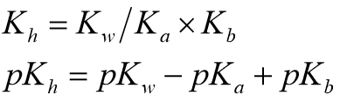

**Buffer System**

Is a solution of a weak acid and its salt to form acidic buffer solution or weak base and its salt to form basic buffer solution. A buffer solution has the ability to resist changes in pH upon the addition of small amounts of either acid or base.

**Acidic Buffer Solution**

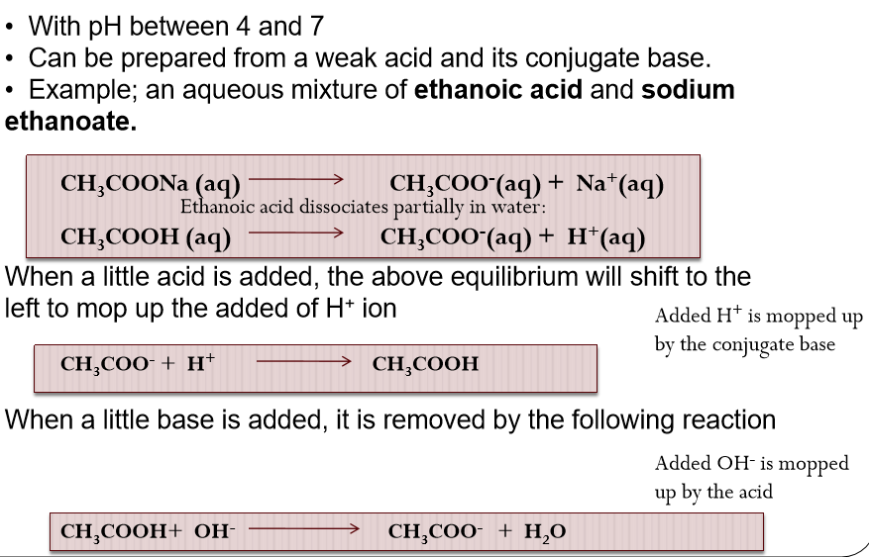

**Basic Buffer Solution**

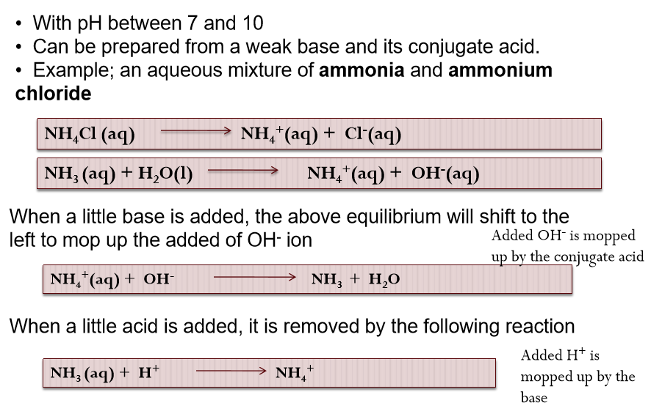

**Exercise**

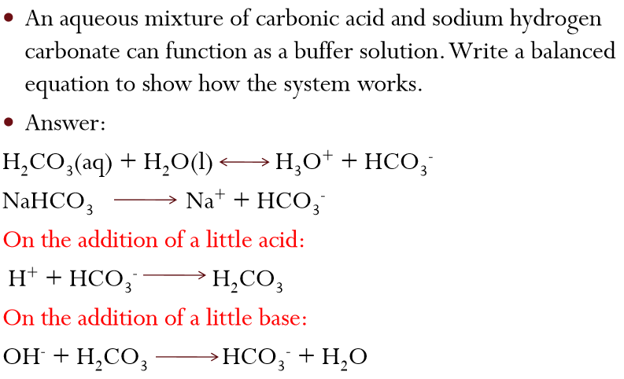

**pH of Buffer Solutions**

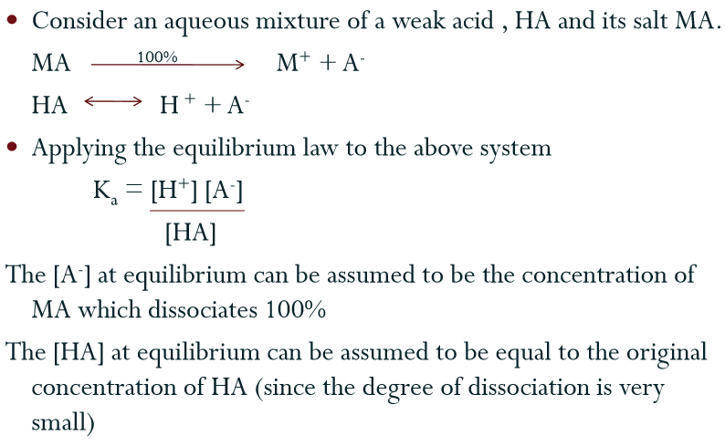

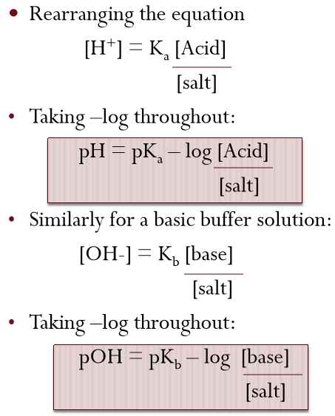

**Theory and application of buffer system Maintaining the pH of blood**

